Programming Fundamentals – Lab Sheet 05
Q1)
- Print numbers from 1 to 10
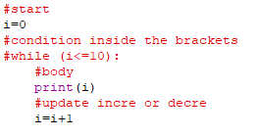
- Print numbers from 10 to 1
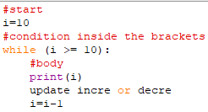
Question 02) Sum of first 10 numbers
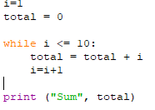
Question 03) Multiplication Table of 5
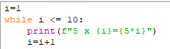
Question 04) Countdown timer
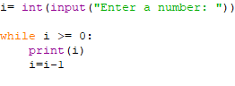
Question 05) Sum of user input numbers (5 values)
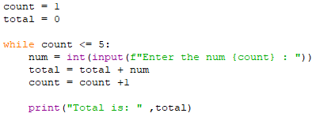
Question 06)
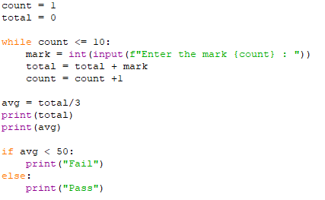
Question 08) Print until user stops

